High performance VLSI implementation of the block cipher
Rijndael algorithm

* Mrs.G.Umamaheswari, ** Dr.A.Shanmugam
*Research scholar, ** Professor,
ECE Department,
PSG College of technology, Coimbatore
Email:gumabhaskar@yahoo.co.in

Abstract

Cryptography plays an important role in the security of data transmission. This paper addresses efficient hardware implementation approaches for the AES (Advanced Encryption Standard) algorithm and describes the design and performance testing of Rijndael algorithm. A strong focus is placed on high throughput implementations, which are required to support security for current and future high bandwidth applications. An optimized coding for the implementation of Rijndael algorithm for 128 bytes has been developed. The speed factor of the algorithm implementation has been targeted and a software code in VHDL which boast of a throughput of 2.1Gbps has been developed. The architectural innovations that have been incorporated in the coding include on the fly round key generation, which facilitates simultaneous execution of sub bytes, shift rows and mix columns and round key generation. This implementation will be useful in wireless security like military communication and mobile telephony where there is a grayer emphasis on the speed of communication.
Keywords: Cryptography, Rijndael, Encryption, Advanced Encryption Standard (AES), pipelining, security, very-large-scale integration (VLSI), VHDL.

1. Introduction

In the Third advanced encryption standard (AES) candidate conference, papers from different research groups were presented [7, 9, 10].The main purpose of these works was the evaluation of the AES finalist algorithms in terms of hardware implementation performance. United States National Institute of Science and Technology (NIST) had chosen Rijndael algorithm as the AES from the finalist algorithms - MARS, RC6TM , Serpent, Rijndael & Twofish in October 2000 [1,20].In this paper VLSI implementation of AES proposal are presented. Although many encryption algorithms can be relatively efficiently implemented in software on general-purpose or embedded processors, there is still a need for special purpose cryptographic processors. Different applications of the AES algorithm require different speed/area trade offs. Some applications such as WWW servers and ATMS are speed critical, smart cards and cellular phones require small area and other applications such as digital video recorders require an optimization of speed/area ratio. In mobile application like cellular phones, PDA’s, etc,.Software implementation [1] on general-purpose processors consumes much more power than special purpose ASIC's do. The high performance is especially reached by keeping combinational paths balanced so that every clock cycle is fully utilized.
The paper is organized as follows. In section 2, the cipher Rijindael is described. In section 3, the architecture is presented in detail. Performance analysis and comparison results with other works are reported in section 4.Finally concluding remarks are made in section 5.
2. The RIJNDAEL algorithm
On August 20, 1998, NIST announced a group of fifteen finalists entries, and from that group five algorithms were selected for further analysis. NIST evaluated the candidate algorithms and received invaluable assistance from cryptographers at computer security companies and universities around the world. Good security was the primary quality required of the winning formula, but factors such as speed and versatility across a variety of computer platforms also were considered. In other words, the algorithms must be able to run securely and efficiently on large computers, desktop computers and even small devices such as smart cards. The two researchers who developed Rijindael are both cryptographers from Belgium: John Daemen and Vincent Rijmen. The following comments are from homepage which describes the criteria used for final evaluation.Rijndael appears to be consistently a very good performer in both hardware and software across a wide range of computing environments regardless of its use in feedback or non-feedback modes. Its key setup time is excellent, and its key agility is good. Rijndael's very low memory requirements make it very well suited for restricted-space environments, in which it also demonstrates excellent performance. Rijndael's operations are among the easiest to defend against power and timing attacks.The AES is a round based symmetric block cipher. It takes a 128 bit data block as input and performs several transformations on this block [4, 6, 12]. A 128 bit input and output block of the AES is mapped to an AES state by putting the first byte of the block in the upper left corner of the matrix and by filling in the remaining bytes column by column. A round consists of a fixed sequence of transformations. Except for the firs round and the last round, the other rounds are identical and consist of four transformations. The four transformations are invertible, hence the round itself is invertible. The Fig 1 shows the steps of the encryption process for 128 bit key.

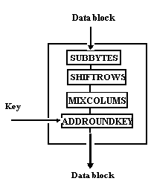
D_{0,0} | D_{0,1} | D_{0,2} | D_{0,3}
D_{1,0} | D_{1,1} | D_{1,2} | D_{1,3}
D_{2,0} | D_{2,1} | D_{2,2} | D_{2,3}
D_{3,0} | D_{3,1} | D_{3,2} | D_{3,3}
(a) (b)
Fig.1 (a) Structure of the one round (b) AES state

AddRoundKey
AddRoundKey is an XOR between the state and the round key. This transformation is its own inverse.
SubBytes
Subbyte is a substitution of each byte in the block independent of the position in the state. This is an S-box. This is the non-linear transformation. The S-box used is proved to be optimal with regards to non-linearity. The S-box is based on arithmetic in GF (2⁸).
ShiftRows
ShiftRows is a cyclic shift of the bytes in the rows in the state and is clearly invertible (by a shift in the opposite direction by the same amount).
MixColumns
Each column in the state is considered a polynomial with the byte values as coefficients. The columns are transformed independently by multiplication with a special polynomial c(x). C(x) has an inverse d(x) that is used to reverse the multiplication by c (x).
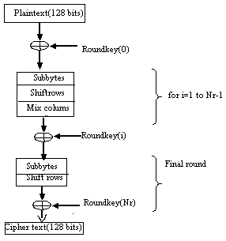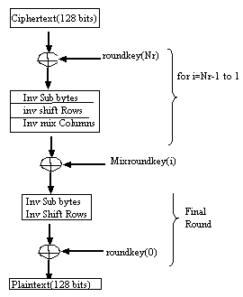
(a) (b)
Figure 2. AES algorithm
(a)Encryption Structure (b) Decryption Structure

In Fig 2(a) and (b) encryption and decryption structure are shown. The decryption structure has exactly the same sequence of transformation as that in the encryption structure. This feature enables more efficient implementation of joint encryptor/Decryptor.

3. Design and implementation

A wide variety of architectures could be used to implement a given algorithm[2,3,24]. Some hardware should be duplicated to achieve higher performance. The largest component is key shedular.The pipelined architectures duplicate the internal functions of the block ciphers. The parallel architectures. In this design, two fundamental architectures were chosen: iterative and pipelined. All algorithms (Key gen, Encryption and decryption) were designed in each architecture style. There are several variations on these approaches, including multiple copies of an iterative implementation for parallel processing, a partially pipelined implementation, or a combination of these hybrids (multiple copies of a partially pipelined implementation).VHDL modeling is analogous to programming simulation in C code [10] and follows much of the same syntax. However unlike the behavioral description of the algorithm, VHDL specifies how the algorithm will be implemented in hardware [. Also, unlike full custom design, optimizations and changes can be made quickly and easily. This allows for a high degree of scalability and controllability of the parallel architecture.
Design principles
- Symmetry in encryption and decryption
- Protects against chosen plaintext and chosen cipher text attacks
- Linear mixing layer (shift row and Mix column) which guarantees high diffusion
- Non linear S boxes protects against linear and differential cryptanalysis
The Rijndael process itself executes only the encrypt or decrypt algorithm, according to the case. The others processes only provide support to read and write bus operation and to round keys generation. The Data In process gives support to Rijndael. It is used to take the data from the bus. It is controlled by the WrD and Clk signals. When the bus put a data to be read, this signal is selected and the data is taken. Fig 3 shows the general encryption and decryption structure.

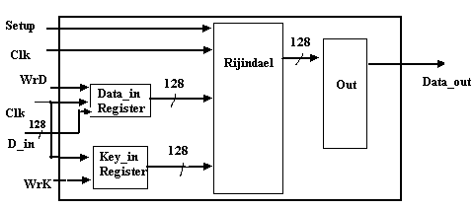

Figure 3. Encrypt/decrypt architecture.
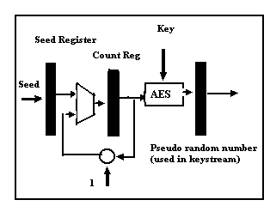

Fig 4. Counter mode of operation

The Counter (CTR) mode is a confidentiality mode that features the application of the forward cipher to a set of input blocks, called counters, to produce a sequence of output blocks that are Exclusive-ORed with the plaintext to produce the ciphertext, and vice versa. The sequence of counters must have the property that each block in the sequence is different from every other block. Pipelining is a general method of increasing the amount of data processed by a digital circuit in a unit time. The idea is to introduce evenly spaced extra registers as shown in Fig.5 in the middle of the combinational circuit, in such a way that several blocks of data can be processed by the circuit at the same time. In each clock cycle the partially processed data blocks moves to the next pipeline stage. This circuit can encrypt simultaneously as many blocks of data, as the number of pipeline stages it contain which further limits the circuit speed-up. The system architecture is shown in Fig 7. The pipelined architecture can increase the speed of Encryption/Decryption by processing multiple blocks of data simultaneously. The key of the AES algorithm can be mapped to 4 rows of bytes in a similar way, except the number of bytes in each row denoted by Nk can be 4,6 or 8 when the length of the key ,K is 128,192, or 256 bits ,respectively.

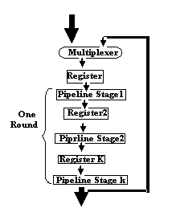
Fig 5.Pipelined architecture

The AES algorithm is iterative algorithm. Each iteration can be called a round. The total number of rounds, Nr, is 10 when Nk=4, Nr=12 when Nk=6, and Nr=14 when Nk=8.The data permutation or S-box computation is an important operation among several others of AES system according to its resource consumption. Its efficient implementation can dramatically increase system performance since the algorithm has to perform this operation every round. Moreover the S box computation is also required in the key scheduling. In this design, there is only one hardware for encryption round and reuse the same piece of hardware to complete the whole encryption process. The 128 bit data is broken down into 16 chunks, 8 bit each, and each of them is used as the address for S-box table lookup. The S-box contains 128 entries, and each entry is 8 bits wide. In order to achieve parallelism and finish one round of encryption in one clock cycle, the same S-box is duplicated 16 times as shown in Fig 6. Instead of calculating the sub bytes sequentially, which consumes a lot of time, the 16 sub bytes can be calculated in one go and hence reduces the time of operation tremendously.

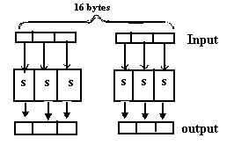
Figure.6. Block diagrams for Substitution

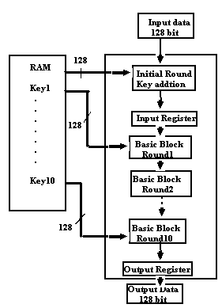

Fig 7.System architecture

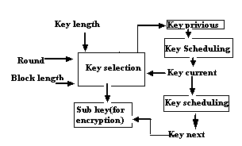

Fig 8. Key-scheduling overall architecture
The Key Scheduling Component shown in Fig 8. Performs the Round Key generation. This round key is generated dynamically each round based on the previous rounds key. Implementations of cryptographic algorithm in hardware have several advantages over software implementation[16,19] including speed and security. The ideal goal would be to have this AES hardware implementation be embedded on a Wireless Network Adapters for PCs and Laptops. Ultimately, this could relieve enough time from the processor to enable faster communication rates and generally both speed up and secure wireless communications.

4. Performance Analysis

The proposed architecture was implemented by using VHDL.The implementations were simulated for the correct encryption and decryption operation using the test vectors provided by the AES submission package [4,11].The VHDL code of the design is synthesized, placed and routed using target device of Xilinx.The architecture was simulated for verification of the correct functionality. The measurements of the performance analysis are shown in Table I .Measurements from other designs are added in the same table. Throughput: How many data information the device can process in a second. It is important to determine the amount of data that the channel can use with cryptography. The throughput is calculated with the following formula:
Throughput=block size * frequency/total clock cycles
The standard 128-bit key and 128-bit data block size. Therefore, the Control Component allows for only 10 rounds of AES encryption and implemented on Xilinx’s Web pack version 6.2i[21,22].The number of cycles per encryption block is 8.The maximum clock frequency is 130Mhz.The encryption and decryption throughput is given by 2.1Gbps.

Table I .Hardware oriented developments of Rijndael block cipher

Design | Thro  (Gbps) | Thro/area | Area slices
Virtex[20] | 1.75 | 2.27 | 770
Amp[14] | 0.29 | 0.68 | 421
Amp[18] | 1.06 | 1.85 | 570
Helion[13] | 1.19 | 2.64 | 450
Proposed | 2.18 | 3.98 | 548

he parameters that we use to evaluate the quality of
device is shown in Table II. Virtex is one of the latest in a series of high-performance FPGAs fromXilinx []. Virtex architecture comprises of an array of Configurable Logic Blocks (CLBs), encircled by programmable I/O blocks, and dedicated block memories of 4096 bits each.

Table II.Performance analysis Measurement

Parameters | Standard[2] | proposed
critical path | 10ns | 10.443ns
gate count | 173,000 | 174,000
throughput | 1.82 Gb/sec | 2.18Gb/sec

(a) (b)
Fig.6 Performance metrics (a) Area (b) Throughput

5. Conclusion

The objective of this paper is to present the hardware implementation of Advanced Encryption Standard (AES) algorithm. The importance of the Advanced Encryption Standard and the significance of high throughput implementations of the Rijindael have been examined. A design methodology was established which in turn led to the architectural requirements for a target FPGA [5, 8, 17]. This architecture supports key expansion unit in the same device and performs efficiently in application with low covered area resources. The whole design was captured entirely in VHDL language. The proposed VLSI implementation of the algorithm reduces the covered area and achieves a data throughput up to 2.1Gbit/sec.Architectural innovations like on the fly round key generation, which facilitates simultaneous execution of sub bytes, shift rows and mix columns and round key generation has been incorporated in our coding. The resulting VLSI circuits achieve data rates significantly high, supporting both operation processes (encryption/decryption) of Rijndael algorithm. The combination of security, and high speed implementation, makes it a very good choice for wireless systems.

References

- W.Diffle and H.Hellman, “Privacy and authentication: An Introduction to cryptography”, Proceedings of IEEE, pp 397-427, vol 67(1979).
- Henry Kuo and Ingrid Verbauwhede, “Architectural Optimization for a 1.82Gbits/sec VLSI Implementation of the AES Rijindael Algorithm”, in3rd international workshop cryptographic Hardware and embedded systems (CHES 2001), LNCS2162, Paris, pp 51-64, May 2001.
- Ingrid and Henry Kuo,“Design and performance testing of a 2.29Gbits/sec Rijindael algorithm”, IEEE Journal of solid state circuits ,vol38,No.3,pp 569-572,March 2003..
- J.Daeman and V.Rijmen, “AES proposal: Rijindael”,
September,2001. http://www.esat.kuleuven.ac.be/~rijmen/rijndael/
- K. Gaj and P. Chodowiec, “Implementations of the AES Candidate Algorithms using FPGA Devices” Technical Report, George Mason University, April, 2000.
- Joan Daemen and Vincent Rijmen, “A Specification for the AES Algorithm Rijndael”, V 3.7, 10th May, 2003.
- J.H.Silverman, “Fast multiplication in finite fields GF (2^{N)}”, Proc.cryptographic hardware and embedded systems, CHES’99, pp122-134, 1999.
- M. McLoone, J. McCanny, “High Performance Single-Chip FPGA Rijndael Algorithm Implementations,” Proceedings Cryptographic Hardware and Embedded Systems Workshop, CHES, Paris, May 2001.
- T. Ichikawa, T. Kasuya, M. Matsui, “Hardware Evaluation of the AES Finalists,” in AES3:the third AES Candidate conference, New-York, April 13-14, 2000.
- B. Gladman, “The AES Algorithm (Rijndael) in C and C++, performance of the optimized implementation”.
http://fp.gladman.plus.com/cryptographytech/rijndael/index.htm.
- “Third advanced encryption conf”,http://crscr.nist.gov/encryption/aes/round2/conf3/aes3conf.htm.Apr2000.
- NIST (FIPS) PUB 197, Advanced Encryption Standard (Nov 2001). http://www.nist.gov/aes.
- Helion Technologies. High Performance (Rijndael) cores, 2001.
- Amphion Semiconductor. CS5210-40: High Performance AES Encryption Cores, 2001. http://www.amphion.com/cs5210.html
- A.J. Elbert, E. Yip, B. Chetwynd, C. Paar: “An FPGA Implementation and Performance Evaluation of the AES Block Cipher Candidate Algorithm Finalists”, IEEE Transactions on VLSI, August 2001, vol. 9, no. 4, pp. 545-557.
- Dai, Wei. Speed Comparison of Popular Crypto Algorithms. Performance of Crypto algorithms in software, http://www.eskimo.com/~weidai/benchmarks.html (2001).
- Mroczkowski, Piotr. Implementation of the block cipher Rijndael using Altera FPGA. PDF file available via WWW in (2001).
- http://csrc.nist.gov/encryption/aes/round2/comments/20000510-pmroczkowski.pdf
- [LOM00] Lomont, Chris. AES – Advanced Encryption Standard. Software performance of the Rijndael, http://www.math.purdue.edu/~clomont/software/AES/AES.htm (2001).
- [NSA00] NSA. Hardware Performance Simulations of Round 2 AES Algorithms.
- Xilinx Webpack 5.1 software,http://support.xilinx.com
- http://www.xilinx.com/xlnx/xweb/xil_publications_index.jsp, Xilinx website
- http://www.esat.kuleuven.ac.be/~rijmen/rijndael, Rijndael developers website

