Intelligent Software Agent Technology
-For a secure & Efficient Distributed Applications
Biswajeet Sahu
B.tech,Computer Science & Engg.
B.S.A.College ofEngg.&Tech.,Mathura
(Affiliated to U.P.Technical University)
c/o Sri Mukut Bihari Sharma
36,Agrasen Nagar,Dwarika puri
Mathura-281004
+919412492704
biswajeet_sahu@yahoo.com

ABSTRACT
“As we know the thing seems to be very simple from outside, the technology behind is much complex”
From procedural Oriented approach to Agent oriented approach, software technology take a giant step. agent technology is the latest approach to analyzing ,designing and building software. In this paper, we will lead you into the world of software agents, an emerging technology that makes it very much easier to design, implement, and maintain distributed systems.. The life cycle model of the leading mobile agent system (Aglets) is task based. This ties itsusers into a single model which reduces their flexibility to implement their ownsystem/application specific life cycle models These applications were chosen to give a flavor for the usefulness and power of the technology- Electronic Commerce with Business Adaptation.
. We are entering a new electronic world from object oriented software methodology to Agent oriented software methodology that is overloaded
Keywords
Software Agents, , Mobile agent system ,Agent Models, robust remote interactions Electronic Commerce,. Implementation tools

1.INTRODUCTION
Agent based systems are one of the vibrant and exciting areas of research and development emerged in information technology in the 1990s. In September 1996, Broadcom Ireland formed a research collaboration with the Computer Science Department in Trinity College Dublin., in order to explore current research in the domain of Intelligent Agents and to apply this technology to applications in communications In this scenario, mobile agents have been proposed as a model to cope with the requirements of wide distributed applications.

2.SOFTWARE AGENT
Agents can be autonomous entities, deciding their next step without the interference of a user ,or they can be controllable ,serving as a me diary between the user and another agent, thereby having some amount of Artificial Intelligence
An agent is simply another kind of software abstraction, an abstraction in the same way that methods, functions, and objects are software abstractions. An object is a high-level abstraction that describes methods and attributes of a software component.. We may also say that” Agents can exist in a structure as complex as the global Internet or one as simple as a module of a common program.”
3.CHARACTERTICS OF AGENTS
There are many possible conceptions of Agent . Characteristics . of Agents Include:-
3.1)Proactive ness:-The agent has an agenda to pursue and will persist in trying to achieve its aims.
3.2)Autonomy:-It enables an agent to perform a job or step without direct intervention of its user and it has full control over its actions and internal state.
3.3)Mobility:-It can passes the ability to move from place to place in a network like Internet .It can move itself and execute afresh at a new location.
Sometimes an agent performs a task at one location ,saves the state ,migrates to a new location and restores its execution state to continue where it left off
3.4)Intelligence:- An agent displays intelligence by reasoning from the goal and knowledge it has . It can learn from its environment and change its behavior through experience and adapt itself.
4. AGENT MODEL
This model defines the internal structure of the intelligent agent part of a mobile agent;.
4.1 Life-cycle model
This model defines the different execution states of a mobile agent and the events that cause the movement from one state to another. Thus, it is closely related to the computational model
which describes how the execution occurs. The first, and more powerful life cycle , starts with a ‘start’ state, proceeds to a ‘running’ state where a persistent process is executed, and hopefully enters a ‘death’ state where the process is terminated. When a mobile agent is transported from one node toanother, the process in the running state is check-pointed e agent enters the ‘frozen’ state. Next, its context is delivered to the destination node where the process is resumed and re-enters the ‘running’ state at the point it left off. This kind of life cycle is the most powerful and flexible life cycle as all other life cycle models can be built on top of thisThe task based starts in the ‘start’ state. Then depending on a set of conditions is proceeds through a network of tasks. Each task having its own state. However, when the agent moves to a new node the context of the currently executing task is lost. Before bmoving the agent must indicate the first task to be started when it re-materialises on the destination node.
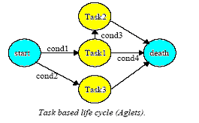
fig4.Mobile Agent System

5.1)”MOBILE AGENT SYTEM IN, CLIENT SERVER AGENT SYSTEM OUT”

-Getting ahead of the evolutionary path

. In particular, although full mobile-agent systems involve all the same research issues (and more) as more restricted mobile-code systems, y. I will be explain a brief overview and comparison of two system for distributed computing: client-server, and mobile agents
.
5.1.1..Client-Server System.
In the client-server paradigm, see Figure 3, a server advertises a set of services that provide access to some resources (e.g., databases). The code that implements these services is hosted locally by the server. We say that the server holds the know-how. Finally, it is the server itself that executes the service, and thus has the processor capability. 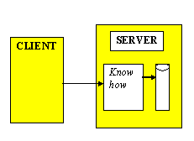
fig 3.Client –Server System
If the client is interested in accessing some resource hosted by the server, it will simply use one or more of the services provided by the server. Note that the client needs some "intelligence" to decide which of the services it should use. The server has it all, the know-how, resources, and processor. So far, most distributed systems have been based on this paradigm.
5.1 .2Mobile- Agent System
A key characteristic of the mobile agent paradigm, see
Figure 4, is that any host in the network is allowed a high degree of flexibility to possess any mixture of know-how, resources, and processors. Its processing capabilities can be combined with local resources. Know-how (in the form of mobile agents) is not tied to a single host but available throughout the network.
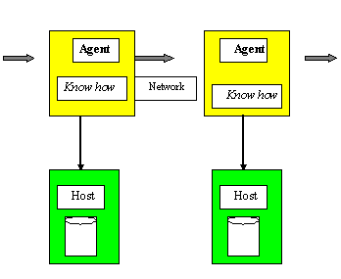
fig4.Mobile Agent System

5.2.2Advantages of mobile agents over traditional client-server designs
This section discusses several relative advantages of mobile agent systems over conventional client-server design principles...
5.2.3.1.Reduction of Network Load:-
Mobile agents are also useful when it comes to reducing the flow of raw data in the network. When very large volumes of data are stored at remote hosts, these data should be processed in the locality of the data, rather that transferred over the network. Mobile agents allow you to package a conversation and dispatch it to a destination host where the interactions can take place locally, see Figure 1.

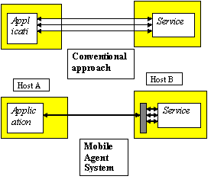
fig.4.Reduction of Network Load by using agents
5.2.3.2Support for disconnected operation and weak clients
Mobile agents improve the support for mobile computing, i.e., mobile devices that are only intermittently connected. Mobile devices, such as personal digital assistants (PDAs), web pads, and mobile phones, are not general-purpose computing devices in the sense of personal computers, but exhibit two key characteristics relevant in this discussion:
- Non-persistent and/or low-bandwidth connection to the network.
- Limited storage and processing capacity.
A user might choose to put together a query (a "task" for the agent), connect to the network, launch the agent with the respective task, disconnect from the network, and at a later time retrieve the agent along with the results it has collected. This is beneficial not only when considering devices that are occasionally disconnected but also when looking at devices, like cell phones, that might be connected persistently, but only with a very low bandwidth.

5.2.3.2 Robust remote interaction
RPC-based client-server computing was developed for LAN-based systems, where strong assumptions regarding communication integrity and server/infrastructure availability could be made. These assumptions are not valid in their strong form when moving from LAN structures to wide area networks (WAN), leading to reduced reliability of RPC-based client-server applications. Although RPC itself could be enhanced to better cope with such new environments, it would take great efforts to adopt all existing components to the improved protocol. Two properties of the mobile agent paradigm offer advantages in this field:
- Messaging- As opposed to RPC, messaging is dependent on reliable communications to a much lesser extent, because it does not require the receiver to answer a message before the sender continues processing.
- Recovery- Mobile agents by nature have to deal with required servers or services being unavailable. Therefore, mobile agents have to carry the ability with them to deal with such situations, i.e., they have to "know" alternatives or how to find them.
.6.Application of Agent technology
6.1 Information Retrieval Agents
Although the architecture diagram shown in Figure may appear at first glance to be rather similar to that of the first class of system discussed in the previous section, the inclusion of the arrow indicating a flow of communication from the interface agent to the information resources reflects a significant step up in sophistication. This is the first class of system that exhibits a significant degree of proactively. The extra arrow on the reference architecture indicates that the interface agent requests particular pieces of information from the information sources, rather than passively filtering information presented to it.
Fig.5 A Reference Architecture for Information Retrieval Agents

This approach lends itself particularly nicely to being implemented using a multi-agent system. Using this approach each separate information source would be modeled by an agent and the interface agent would broadcast a request for information. Upon receipt of such a request each information agent would reply with a Message containing all the information they have access too with relevance to the initial request. The interface agent, having received all these separate pieces of information, is
responsible for aggregating the information sensibly and presenting the information in a unified and easy to access fashion. This approach brings with it a number of benefits to compensate for the added complexity. Chiefly it allows us to deal with distributed sources of information effectively, for example the World Wide Web. It also brings benefits in terms of scalability in that the problems associated with incorporating a new knowledge source are greatly reduced as we simply need to design a new agent and slot it in. Systems of this complexity are very thin on the ground. It is clearly of importance that the information requested satisfies the users query or goals. Thus the request sent by the interface agent
must be based both on the information obtained directly from the interface and also upon any user model the system has managed to build up. This involves the provision of multimedia kiosks at several sites around Ireland drawing social welfare and employment information from a number of distributed knowledge sources.
A number of systems attempt to provide virtual newspapers which draw information from a number of different sources based upon a user’s expressed interests. This type of system differs from the traditional newspapers in that the user of the system explicitly chooses what information should be
present in their own personal newspaper.. This allows the newspapers to remain up to date although typically at the expense of the in-depth analysis of the relevant issues mentioned earlier.. Newshound provides a
somewhat different service which is charged for. Here the users enter keywords which tell the system what news items they are, possibly are and definitely are not interested in. Again the system returns news articles drawn from a variety of online news sources (mainly newswires)..
6.2-ECommerce
software agents are an integral part of the overall system and method of approach. There are user agents acting on behalf of the consumer and business agents representing the suppliers. Although currently beyond the state of the art, it will not be long before users will be able to delegate to their software agent the task of getting cinema tickets to see one of the latest releases on Saturday night and then booking a meal in a nearby restaurant afterwards. Given this objective and knowledge of its user’s preferences (eg vegetarian, no spicy
food, comedies rather than action films, etc.), the proxy will enter the appropriate electronic marketplace where it will encounter the business agents (see figure 6)..
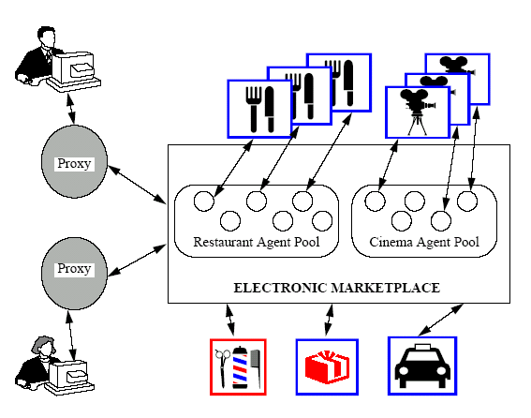

fig.6 The Electronic Marketplace

The proxy will first query the cinema agents to determine the most appropriate film and the most convenient showing time. Having made this decision, the proxy will then progress onto the restaurant agents to see which one best fits with the user’s preferences and constraints. If no appropriate restaurant can be found, the proxy will return to the cinema agent pool and reassesses its choice of film or show time and then repeat the
process. Eventually, if successful, the proxy will report back to the user with the cinema and restaurant booking information.— they are delegated a high-level task which they have to complete on their own (autonomy), they need to interact and negotiate with other service providing agents (social ability), if the preferred restaurant is fully booked the proxy should try another one (responsiveness),and the proxy might voluntarily check with the railway company agent to find out the time of the last train home from the station nearest the restaurant (proactive ness).

7.Business Adaptation
A potential evolution of business adoption of Agent technology is depicted as below:-
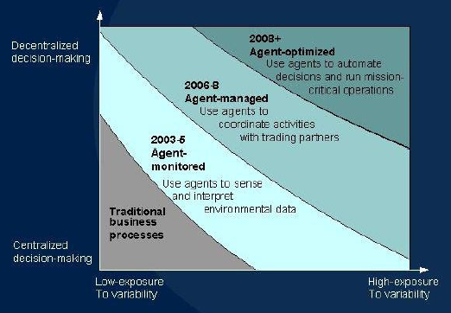
fig7 business adaptation
A clear need is emerging across many industries
however with increasing outsourcing, fickle demand, and shortening product lifecycles: each of these factors is increasing the volatility of markets and hence puts a high
premium on the flexibility of business systems. Particular areas in which agent technology appears to be most appropriate include those which require continuous
adaptation, interpretation of large amounts of data, automated assistance in decision making, multi-firm processes and improvements in corporate learning.

8..IMPLEMENATATION TOOLS

8.1 AgentTcl
AgentTcl is a simple platform independent mobile agent system. Currently it lacks the same degree of sophistication that the Aglets system has achieved. It is built on top of the Tcl/tk scripting system and lacks the power and flexibility of a full computer language such as Java. The agent model is simply a Tcl script, hence its computational model
is based on the Tcl/tk scripting language. The navigation model is based around a single command agent jump. This command can appear anywhere in an agent and will cause all its state and execution context to be frozen and transported to a specified host. This ability to transport the execution context gives Tcl agents a more sophisticated life-cycle model than Aglets..
8.2 Java
The Java environment is a new approach to distributed computing. It is an interpreted, object-oriented language and library set.Its main features are:
-   Simple and familiar object-oriented language.
-   Architecture neutral, portable and robust system.
-   Interpreted and dynamic program execution.
-   A comprehensive, but not perfect, security system.
-   Multithreaded execution with synchronization between threads.
-      Support for distributed systems through the Remote object invocation (RMI) and Object
serialization (OS) facilities. Taken individually, the characteristics discussed above can be found in a variety of software development environments. What's completely new is the manner in which Java and its run-time system have combined them to produce a flexible and powerful programming system which supports distributed computing.
Java, on the other hand, contains no mobile agents. It is simply an enabling technology for mobile agents.
8.3 Aglets
The aglet system represents the next leap forward in the evolution of executable content on the Internet, introducing program code that can be transported along with state information. Aglets are Java objects that can move from one host on the Internet to another. Aglets is a comprehensive mobile agent system with the following features:
1. A globally unique naming scheme for agents (navigation/security model).
2. A travel itinerary for specifying complex travel patterns with multiple destinations and
automatic failure handling (navigation model).
3. A white board mechanism allowing multiple agents to collaborate and share information
asynchronously
4. An agent message-passing scheme that supports loosely coupled asynchronous as well as
synchronous peer-to-peer communication between agents

9. CONCLUSION & FUTURE PROSPECTS
From above discussion & explanation we conclude that a software agents especially mobile agent is as an agent that is not bound to the system where it begins execution. It has the unique ability to transport itself from one system in a network to another The life cycle model of the leading mobile agent system (Aglets) is task based.. The agent Technology holds much promise for the future and once used ,will pave the way for more self –aware ,efficient agents that could be deployed in almost every conceivable situation that demands extremely high complex reaction & actions.
The paper has focused on the mobile agents as a new emerging technology to cope with the new scenarios established by the fast diffusion of such wide distributed systems as the Internet. I claim that mobile agents can have a positive impact on the design of distributed applications; although this technology is not mature yet, it has nevertheless proved to be useful to several distributed applications. Mobile agent approach to software architecture allow organizations to build autonomous components, making them totally flexible and able to operate at any scale.

10. REFERENCES
[1] Developer IQ-Software Agent Technology towards Mainstream Computing,jully-2003.
[2] Mobile Agent Technology Current Trends and perspectives
G . Cabri, L. Leonardi, F. Zambonelli1
[3] Digit Magazine-Agent oriented programming
[4]Mobile agent for Mobile Computing,www.cs.darthmouth.edu
[5] Mobile agents in distributed information retrieval
Brian Brewington, Robert Gray, Katsuhiro Moizumi,
David Kotz, George Cybenko and Daniela Rus
Thayer School of Engineering / Department of Computer ScienceDartmouth College
[6] Applying Agent Technology
Nicholas R. Jennings Michael Wooldridge
Department of Electronic Engineering Department of Computing
Queen Mary and Westfield College Manchester Metropolitan University
[7]http://www.genmagic.com/MagicCap/

[8]http://www.umich.edu/~rsug/ldap/ldap.html

[9]http://www.agent.org/

