FAULT TOLERANT IRREGULAR AUGMENTED SHUFFLE NETWORK

Harsh Sadawarti¹, P.K. Bansal²
¹Asstt. Prof. Deptt. of Computer Science & Engg., RIMT-Institute of Engineering & Technology, Mandi Gobindgarh, Punjab, India, harshsada@yahoo.com., Tel :+91-1765-241405
²Principal, GZCET, Bathinda, Punjab, India
1 INTRODUCTION

A new class of irregular fault tolerant multistage interconnection network named Irregular Augmented Shuffle Network (IASN) has been proposed and analyzed in this paper. As the network is irregular, 50% of the requests pass through minimum path length of 2 in comparison to the regular networks, which have a constant path length. Thus, the irregular network IASN helps in reducing the latency or delay. Moreover, the network is fault tolerant i.e. it is capable of serving requests even in presence of certain faults. IASN has been designed in a way to improve the performance of the network.

2 CONSTRUCTION PROCEDURE OF IASN
Irregular Augmented Shuffle Network (IASN) of size NxN is constructed of two identical subgroups consisting of N/2 sources and N/2 destinations, denoted as G^{i} (where i =0,1). The two groups are formed on the basis of most significant bit (MSB) of the source-destination pair. If the MSB of source-destination pair is 0, then it belongs to G⁰ group otherwise if MSB is 1, then it belongs to G¹ group. Both the groups are connected to the N sources and N destinations with the help of multiplexers and demultiplexers.
IASN network is an irregular multistage interconnection network. An NxN (2^{n} x 2^{n}) network (where N is the number of sources and destinations, n = log₂ N) consists of m stages (where m = log₂ N/2). The first and the last stage of the network consist of equal number of switching elements (SEs) that is 2^{n} ⁻¹ each whereas the intermediate stages consist of less number of switching elements equal to 2^{n} ⁻² each. The switches in the last stage are of size 2x2 and the rest switches from stage 1 to m-1 are of size 3x3. Thus, the total number of switches are equal to 2^{n} ⁻²(m+2) out of which 2^{n} number of switches are of size 2x2 and (m-2)x 2^{n-2} number of switches are of size 3x3. There is one 4x 1 multiplexer for each input link of a switch in first stage and one I x2 demultiplexer for each output link of switch in the last stage. Hence, there exists 2N multiplexers and demultiplexers of size 4x I and I x2 respectively.
Fig 1.1 and Fig 1.2 shows the construction of IASN for size N= 16 and its corresponding redundancy graph respectively.
Redundancy graph is a method of showing all possible paths between source and destination pairs. It depicts the various paths available for routing so that if a particular path is faulty, routing can take place through alternate paths available. Redundancy graph of IASN network as shown in Fig 1.2 depicts the
various possible paths available in the network.

3 ROUTING PROCEDURE FOR IASN
Algorithm: Fault Tolerant Routing for IASN
PROCEDURE
- One of the networks G^{i} is selected on the basis of most significant bit (MSB) of the destination address for routing the request to a particular destination.
- For each source-destination pair, there exist two paths called primary and secondary path. Firstly, the request tries to enter through the primary path. If the primary path is faulty, then the secondary path is chosen. And if secondary path is also faulty, then the network fails.
- The routing tag bit is the destination address with its MSB removed. This tag bit determines the path that is chosen for routing a request from source to destination.
- If a particular output link is faulty or the switch in the next stage is faulty, then the request is passed to another switch in the same stage through a third I ink called auxiliary or express link. If this auxiliary link is also faulty, then the request is dropped.
- At the end, for routing the request through the demultiplexer, bit d₀ of the routing tag is used.

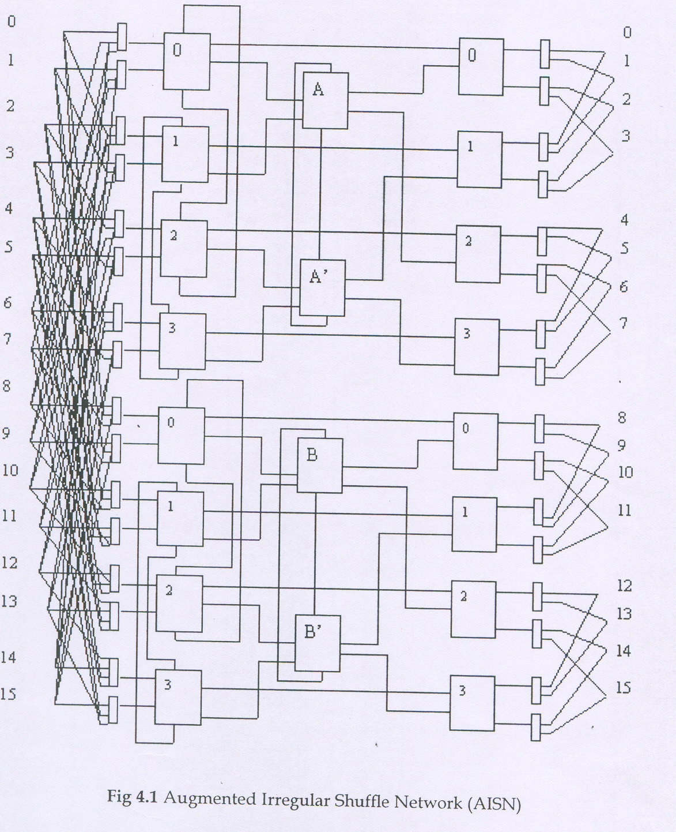

Fig. 1.1 irregular augmented shuffle network (IASN)

Source
Destination

Fig. 1.2 Redundancy Graph of IASN
4 FAULT-TOLERANCE OF IASN
Fault tolerance in an interconnection network is very important for continuous operation over relatively long period of time. Fault tolerance is the ability of the system to continue operating in the presence of faults although at a degraded performance . These faults can be either permanent or transient in nature . It is criteria that must be met for a network to operate even in presence of certain faults.
The network should be able to satisfy the criteria of full access that is ability of the network to transfer data from any input terminal to any output terminal. In case of fault-free conditions, one to one connection is maintained and in presence of faults alternate paths are chosen for routing. So, under the criteria of full access a network is assumed to be faulty if there is any input-output pair that cannot be connected with each other due to the presence of faulty components in the network.
The proposed IASN network satisfies the fault tolerance criteria as it can operate even in presence of certain faults. Fault tolerance has been achieved by providing a primary as well as secondary path from source to destination so that if the primary path is faulty, then secondary path can be chosen. Every source-destination pair has a fork available at every stage except at the last one.
The presence of the auxiliary links available in the network provides an alternate path for routing, except at the last stage. But if the switches in the same loop are simultaneously faulty, then it disconnects certain source-destination pairs. Such a fault is termed as 'critical fault'. So as long as the fault is not critical, the network continues to operate even though at degraded performance. Hence, strictly speaking IASN network is single switch fault tolerant.
The multiple paths between S = 0000 and D = 0110 and between S = 0000 and D = 1010 are as shown in Fig 1.3.
The following theorems characterize the faults that can be tolerated in the IASN network.
Theorem 1 :In IASN network, if the faults occur such that at most one switch is affected in every pair of switches in a loop (that is conjugate switches), then there exists at least one fault-free path from any source to any destination.
Proof: Since there is at most one switch affected in the loop of conjugate switches, the other switch is fault-free. Thus, through the auxiliary or express link, the other fault-free
switch can be reached. As both the switches lead to the same destination, so requests instead of getting blocked pass through the fault-free switch in the same loop. Hence, there exists at least one fault-free path from any source to any destination.
Theorem 2: In IASN, some source is disconnected from some destination if both the switches in a loop are simultaneously faulty.
Proof: Suppose that while routing from any source to any destination there exists a faulty switch in the route. The network will try to route the request through another switch in the same loop. But if both the switches are simultaneously faulty, then clearly some sources will be disconnected from certain destinations.
Lemma I: IASN is single switch fault tolerant in stages from 1 to m-1.
Proof: From stages 1 to m-1, there exists SEs that forms pair through the use of auxiliary links. Some sources will be disconnected from some destinations only if both the switches in the loop are simultaneously faulty. In case of single switch failures, sources are connected to destinations through the other fault-free switch available in the loop. Hence, IASN is single switch fault tolerant network..
5 RELIABILITY ANALYSIS OF IASN
There are three fault models adopted to the reliability analysis of the networks: ' stuck-at fault model', 'switch-fault model' and 'link-fault model'. In the stuck-at fault model, a failure causes a crossbar switch to remain in a particular state regardless of the control inputs given to it, thus affecting its capability to set up suitable connections. In switch fault model, a switch is considered to be totally unusable if it becomes faulty. In the link fault model, a failure affects an individual link of a switch leaving remaining part of the switch operational . Any network fault that corrupts data on the information path is called a link fault. A link fault occurs in an information link when it becomes stuck at either logical "0" or "1", regardless of the actual input signal applied to it. In this thesis, switch fault model is used for the analysis of the network. It is assumed that any of the switching component i.e. switching elements, multiplexers and demultiplexers can fail in the IASN network. All the faults are assumed to be independent of each other. The reliability is analyzed in terms of MTTF. The MTTF is analyzed by defining a set of critical components. A critical set of components is defined as set of switching components, each from different groups, such that a network failure will occur if all the components become faulty simultaneously.

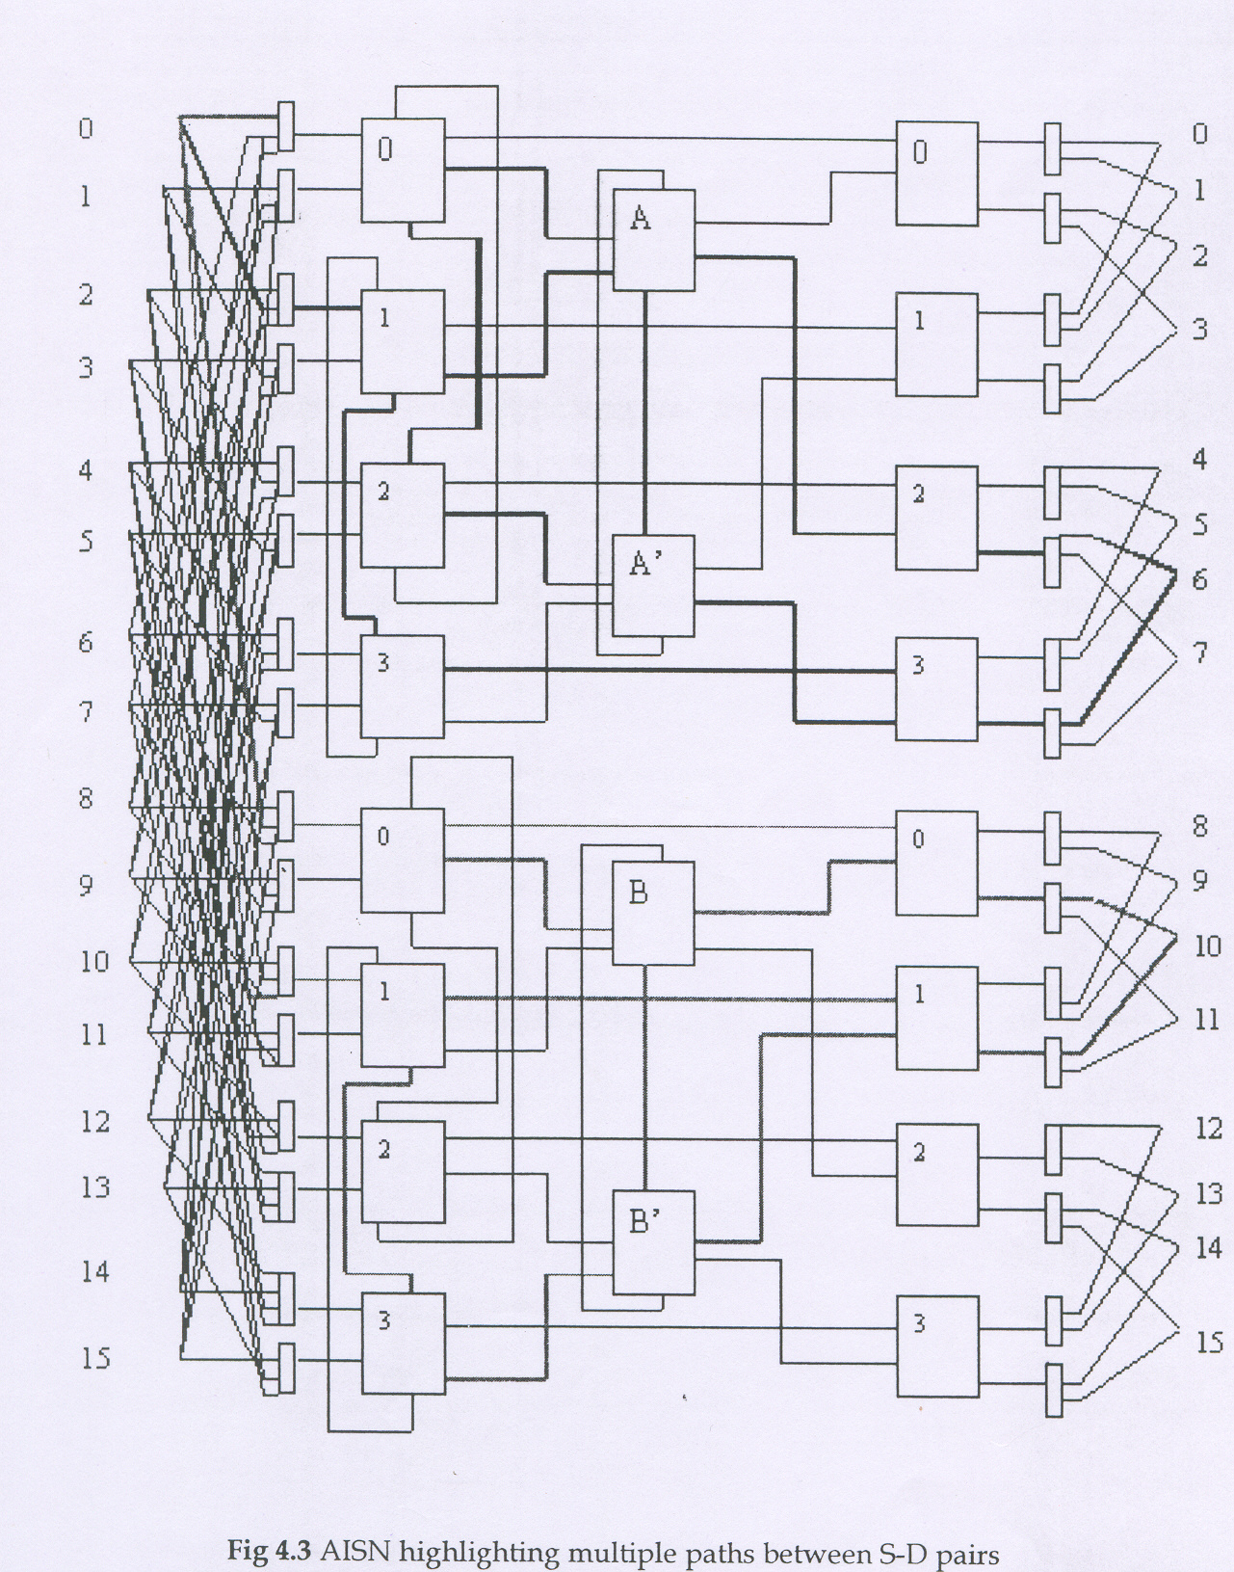
Fig. 1.3 IASN highlighting multiple paths between S-D pairs
Certain basic steps are used in the analysis of reliability. These are:
- First, the elements, subsystem and estimated individual reliability factors are identified.
- Then a block diagram representing the logical manner in which these elements are connected is prepared to form a system.
- Then the condition for the successful operation of the system is determined that is it is decided that how many units should function together.
- Finally the combinational rules of probability theory that is add, multiply and their combinations are applied to arrive at the system reliability factor.
The following assumptions are made during reliability analysis:
Assumptions:
- Switch failures occur independently in the network with the failure rate of $λ\left({\text{10}}^{−6}\text{ per h}\right)$
- Based on the gate count, failure rate of 2 x 2 SE is taken as λ₂=λ; for a 3 x 3 SE it is λ₃=2.5 λ and λ_{m} = mλ/4 for a m x I MUX or λ_{d} (=λm) for a I x m DEMUX.
- 2 x 2 SEs in the last stage and their associated demultiplexers are taken as series system with a combined failure rate of λ_{2d}=2 λ.
5.1 Upper Bound Analysis
This presents the optimistic value of the reliability. In this it is assumed that the network will be operational as long as one of the two multiplexers attached to the source is operational and as long as a conjugate pair of switch is not faulty. The reliability block diagram for the upper bound is as shown in Fig 1.4 (a) and the corresponding. expression is:
$$\begin{aligned}R\text{UB-IASN}\left(t\right)={\left[1−{\left(1−e^{−λ}m^{t}\right)}^{2}\right]}^{\text{N/2}}\text{.}{\left[\text{1-}{\left({\text{1-e}}^{−λ}3^{t}\right)}^{2}\right]}^{\text{N/4}+\text{N/8*}+\text{.}\text{.}\text{.}\text{.}1}\text{.}{\left[\text{1-}{\left({\text{1-e}}^{−λ}2d^{t}\right)}^{2}\right]}^{\text{N/4}} \\ \text{MTTF}=\int_{0}^{∞}{}R\text{UB-IASN}(t)\text{dt}\end{aligned}$$

N/2
copies

N/4+N/8*+…I
copies

N/4
copies

SE₃

SE_{2d}

SE_{2d}
SE₃
SE_{m}

SE_{m}
Fig 1.4 (a) Upper Bound Reliability Block Diagram
The values for the Upper Bound MTTF for the IASN network are provided in Table 1.2.

Network Size  → | 16xl6 | 32x32 | 64x64 | 128xl28 | 256x256 | 512x512 | 1024xl024
PL J.↓
2 | 155945 | 105456 | 72 190 | 49874 | 34686 | 24239 | 16996
3 | 139275
4 |  | 94419
5 |  |  | 64769
6 |  |  |  | 44816
7 |  |  |  |  | 31203
8 |  |  |  |  |  | 21822
9 |  |  |  |  |  |  | 15311
Table 1.2 Upper Bound MTTF for IASN
The values of upper bound MTTF for other networks like ASEN-2 , ABN and FT network are given in Table 1.3, 1.4 and 1.5 respectively.
Network  Size | 16x16 | 32x32 | 64x64 | 128xl28 | 256x256 | 512x512 | 1024x1024
UB | 134935 | 77685 | 47339 | 29855 | 19255 | 12611 | 8353
Table 1.3 Upper Bound MTTF for ASEN-2

Network  Size' | 16x16 | 32x32 | 64x64 | 128xl28 | 256x256 | 512x512 | 1024x1024
UB | 171627 | 91329 | 53434 | 32884 | 20867 | 13511 |  | 8872
Table 1.4 Upper Bound MTTF for ABN

Network  Size | 16x16 | 32x32 | 64x64 | 128x128 | 256x256 | 512x512 | 1024x1024
UB | 171627 | 115276 | 78546 | 54084 | 37525 | 26178 | 18334
Table 1.5 Upper Bound MTTF for FT
5.2 Lower Bound Analysis
In the lower bound analysis each group is considered independently and it is assumed to be faulty if there is single fault in it. The input side SEs and their associated multiplexers are taken as series system and failure of any component is assumed to be failure of all three. Hence, in this the results are pessimistic in nature.
The reliability block diagram for the lower bound is as shown in Fig 1.4 (b) and the corresponding expression is:
$$\begin{aligned}RL\text{B-IASN}\left(t\right)={\left[1−{\left(1−e^{−λ}3m^{t}\right)}^{2}\right]}^{\text{N/4}}\text{.}{\left[\text{1-}{\left({\text{1-e}}^{−λ}3^{t}\right)}^{2}\right]}^{\text{N/4*}+\text{N/8*}+\text{.}\text{.}\text{.}\text{.}1}\text{.}{\left[\text{1-}{\left({\text{1-e}}^{−λ}2d^{t}\right)}^{2}\right]}^{\text{N/4}} \\ \text{MTTF}=\int_{0}^{∞}{}RL\text{B-IASN}(t)\text{dt}\end{aligned}$$

N/4
copies

N/4*+N/8*+…1
copies

N/4
copies

SE₃

SE_{2d}

SE_{2d}
SE₃
SE_{3m}

SE_{3m}
Fig 1.4 (b) Lower Bound Reliability Block Diagram

The values for the Lower Bound MTTF for the IASN network are provided in Table 1.6.
Network Size  →  PL ↓ | 16x16 | 32x32 | 64x64 | 128xl28 | 256x256 | 512x512 | 1024x1024
2 | 117465 | 78067 | 52778 | 36133 | 24966 | 17364 | 12135
3 | 102088
4 |  | 68559
5 |  |  | 46704
6 |  |  |  | 32150
7 |  |  |  |  | 22301
8 |  |  |  |  |  | 15554
9 |  |  |  |  |  |  | 10891
Table 1.6 Lower Bound MTTF for A1SN

The values of lower bound MTTF for other networks like ASEN-2 , ABN and FT network are given in Table 1.7,1.8 and 1.9 respectively.
Network  Size | 16x16 | 32x32 | 64x64 | 128xl28 | 256x256 | 512x512 | 1024x1024
UB | 118383 | 69950 | 43375 | 27700 | 18035 | 11900 | 7928
Table 1.7 Lower Bound MTTF for ASEN-2

Network  Size | 16xl6 | 32x32 | 64x64 | 128xl28 | 256x256 | 512x512 | 1024xl024
UB | 94872 | 53944 | 32667 | 20546 | 13241 | 8676 | 5752
Table 1.8 Lower Bound MTTF for ABN

Network  Size | 16xl6 | 32x32 | 64x64 | 128xl28 | 256x256 | 512x512 | 1024xl024
UB | 142743 | 95166 | 64500 | 44244 | 30613 | 21315 | 14907
Table 1.9 Lower Bound MTTF for FT

From Fig 1.5(a) it can be seen that the Upper Bound MTTF of IASN is comparable to ASEN-2 and ABN for small network sizes but as the network size increases, the MTTF of IASN is better than ASEN-2 as well as ABN. Also from Fig 1.5(c) it can be seen that the Upper Bound MTTF of IASN slightly less than FT network for small network sizes but becomes comparable as the size increases. This implies that IASN is more reliable in comparison to ASEN-2 and ABN network and is comparable with the FT network.
From Fig 1.5(b) it can be seen that the Lower Bound MTTF of IASN is comparable to ASEN-2 but greater than ABN for small network sizes but as the network size increases, the MTTF of IASN is better than both ASEN-2 as well as ABN. Also from Fig 1.5(d) it can be seen that the Lower Bound MTTF of IASN is less than FT network for small network sizes but becomes comparable as large network sizes. This implies that IASN is more reliable in comparison to ASEN-2 and ABN network. IASN is less reliable than FT network for small network sizes and is comparable with FT network for very large network sizes.
Lemma I: IASN is single switch fault tolerant in stages from 1 to m-1.
Proof: From stages 1 to m-1, there exists SEs that forms pair through the use of auxiliary links. Some sources will be disconnected from some destinations only if both the switches in the loop are simultaneously faulty. In case of single switch failures, sources are connected to destinations through the other fault-free switch available in the loop. Hence, IASN is single switch fault tolerant network..

Fig. 1.5 (b) Comparative Analysis of Lower Bound MTTF

Fig. 1.5 (c) Comparative Analysis of Upper Bound MTTF
Fig. 1.5 (d) Comparative Analysis of Lower Bound MTTF

6 CONCLUSION
A fault-tolerant, irregular multistage interconnection network named Irregular Augmented Shuffle Network (IASN) has been proposed. The network possesses fault tolerance capability and hence operates even under presence of faults. It has reduced number of stages thereby exhibiting reduced latency and better performance.

REFERENCES
- Adams G.B., Aggarwal D.P. and Siegel H.J., “A Survey of Fault-Tolerant Interconnection Networks”, IEEE Computers, Vol.20,june 1987, pp.14-27.
- Anderson G.A., Jensen E.D., “Computer Interconnection Networks: Taxonomy, Characteristics and Examples”, ACM Computing Surveys, Vol.7, Dec. 1975, pp. 197-213
- Bansal P.K., Singh K. and Joshi R.C., “Fault-Tolerant Double Tree network”, Proc. Of International Conference IEEE INFOCOM 91, April,pp. 462-468
- Feng T.Y., “Survey of Interconnection Networks”, IEEE Computers, Vol. 4, Dec. 1981, pp 12-27.
- Howard J. Siegel, Wayne G. Nation, Cylde P. Kruskal and Leonard M. Napolitano, “Using the Multistage Cube Network Topology in Parallel Supercomputers”, Proceedings of IEEE, Vol.77, No. 12, Dec. 1979, pp 1932-1953.

