Issues on Multicasting and Token-Rotating for a Load Balancing Scheme for Cluster based Web-Servers.

By-
Abhronil Das Gupta
Anuj Gupta
Vikhyat Srivastava
Vikrant Singh Dogra

(International Institute of Professional Studies,
Devi Ahilya University, Indore, India)

ABSTRACT

Load balancing and fault-tolerance are characteristics desirable in any system of cluster based scalable web servers. Through this paper we intend to address selected issues concerning these cluster based systems. We propose to use the multicasting and a novel token-rotating scheme, to solve the One-IP problem. For fault-tolerance function, we are including an already-proposed scheme of shifting the connection end point. The server is chosen on the basis of content of request and geographic considerations as well as the load conditions of the individual servers. At any given point of time, we can include as many servers as we want, without changing anything in the existing system.

Problem Statement

The challenge is to find an efficient way to balance the load between numerous servers so that no particular server gets clogged. All the servers have to provide one IP address for the clients to connect and the system should be efficient enough to provide failover support. Typical speed bottlenecks, like one receiving point, should be removed.

Related Work

The HTTP protocol is an application-level protocol built for the World Wide Web. It is based on the client/server architecture. For each HTTP request, a TCP/IP connection between a client and a server is established. The client sends a request to a server and the server responds by supplying the requested information. The TCP/IP connection is then closed.

Typically, the server location for an URL is identified by the hostname contained in the URL. To establish a TCP connection, the browser asks the DNS (Domain Name Service) to map the server hostname to an IP address. The IP address together with the port number (default is 80) form the transport address for the HTTP server process.

Based on this protocol, there are many ways to implement request distribution to a number of servers. In general, these servers provide the same set of contents. The contents are either replicated on each machine's local disk, shared on a network file system, or served by a distributed file system. Existing request distribution techniques can be classified into the following categories:

- In the HTTP-redirection approach, a busy server replies with an HTTP-redirection code and provides a new server address to which the client can resubmit its request. This approach is defined in the HTTP protocol. Servers and browsers conforming to HTTP support this mechanism and the redirection is done in a user transparent way. However, by redirection, a request may require two or more connections to get the service, thus this mechanism increases the response time and network traffic.
- The Client-side approach requires each client to have certain knowledge about the server cluster so that requests can be sent to different server addresses in a load-balanced manner. For example, when a Netscape Navigator is used to access Netscape's home page, it randomly picks a number, N, between 1 and 32, and goes to the server at wwwN.netscape.com. However, few companies have the privilege of having the browsers to balance the load on their servers.

Smart Client is another client-side approach. It suggests that the service provide an applet running at the client side. The applet makes requests to several mirror sites to collect information about server loads and other characteristics, and forwards each client request to an appropriate server based on that information. Fault-tolerance and scalability are implemented at the client site. This approach is not client-transparent and it potentially increases the web traffic by sending extra status information from the servers to the client-side applets.

The Server-side DNS approach implements load balancing in the domain name to IP translation process. When a DNS server receives a translation request, it selects the IP address of one of the servers in the cluster in a round-robin fashion. A drawback of this approach is that a translation request may go through a chain of DNS servers, and the name-to-IP mapping is cached by the intermediate DNS servers, which prevents future round-robin effect from reaching the clients. Also, in the event of a server failure, some clients may continue trying to access the failed server using the cached address.

The Server-side single-IP-image approach implements a single IP image to the clients.

The TCP router approach, achieves the single-address image by publicizing the address of the server-side router. Every client request is sent to the router which then dispatches the request to an appropriate server based on load characteristics. The dispatching is performed by changing the destination IP address of each incoming IP packet to the address of a selected server. In order to create a seamless TCP connection, the selected server puts the router address instead of its own address as the source IP address in the replying packets, as shown in Figure 1. The advantage of this approach is that it does not increase the number of TCP connections, and is totally transparent to the clients. However, since the address change is done at the TCP/IP layer, the kernel code of every server in the cluster has to be modified to implement this mechanism. A hybrid of the DNS approach and the TCP-routing approach has also been proposed, in which the DNS server selects one of several clusters in a round-robin fashion.
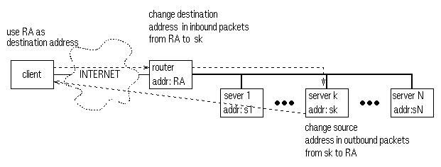
Fig.1. TCP router approach.

The Network address translation approach, is another server-side single-IP-image approach. Two examples are Cisco Local Director and the Magic-router. In this approach, all address changes are performed by the server-site router, including changing the source addresses of the responding packets, as shown in Figure 2.
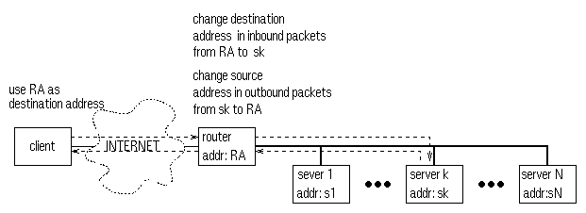
Fig.2. Network address translation approach Compared to the TCP router approach, network address translation approach has the advantage of server machine transparency, i.e., no specific changes from the server machine are required.

The Approach

The client in the internet queries the DNS server regarding the IP address of the known host name of the servers. The DNS server returns a Multicast Group address on which the client “Connects”. Despite the request reaching all the servers, only a particular privileged token-holding server responds. Based on certain set of constraints, the token-holding-server redirects the client to a new server, which will actually process the requests of the client.

Issues on DNS

The mechanism that implements a machine name hierarchy for TCP/IP internets is called the Domain Name System. The domain mechanism for mapping names to addresses consists of independent, cooperative systems called name servers. A name server is a program that supplies name to address translation, mapping from domain names to IP addresses. There are two ways to use a domain name system: by contacting name servers one at a time or asking the name server to perform the complete translation.
When a domain name server receives a query, it checks to see if the name lies in the sub-domain for which it is an authority. If so, it translates the name to an address according to its database, and appends an answer to the query before sending it back to the client. If the name server cannot resolve the name completely, it checks to see what type of interaction the client specified. If the client requested complete translation, the server contacts a domain name server that can resolve the name and returns the answer to the client. If the client requested non-recursive resolution, the name server cannot supply an answer. It generates a reply that specifies the name server the client should contact next to resolve the name [2].

In this model clients send a query to the domain name server which is then resolved by the name server and it returns a multicast address to the client.

Issues on Multicasting

Once the client receives the multicast address, it sends a CONNECT request on the multicast address. IP Multicasting is basically an internet abstraction of hardware multicasting. It follows the paradigm of allowing transmission to a subset of host computers, but generalizes the concept to allow the subset across arbitrary physical networks throughout the internet. In IP terminology, a given subset is known as a multicast group.
The multicast addressing scheme must accommodate two conflicting goals: allow autonomy in assigning addresses, while defining addresses that have meaning globally. IP multicasting defines IP multicast addressing, specifies how hosts send and receive multicast and describe the protocol routers use to determine multicast group membership on a network.
When a server joins a multicast group, it sends an IGMP message to any attached multicast routers telling them that it has just joined that group. The multicast routers then exchange this information using the multicast routing protocol so that each multicast router knows what to do if it receives a packet destined to the multicast address.
Multicasting scope: The scope of a multicast group refers to the range of group members. IP uses two techniques to control multicast scope. The first technique relies on the datagram’s TTL field to control its range. By setting the TTL to a small value, a host can limit the distance the datagram will be routed. Known as administrative scooping, the second technique used to control scoping consists of reserving parts of the address for groups that are local to a given site or local to a given organization.

The Token

It is basically a variable, available with each server, which can get set or reset depending upon a certain set of constraints. It is a system wherein the servers decide it among themselves which server should be serving the client. If the token variable is set, then the server can accept the connection request from a client. On the other hand, if it is reset, then all the connection requests from a client are dropped. The token keeps rotating between different servers depending upon certain constraints. However, at a particular instant of time, only one server can have the token variable set. A particular server leaves the token if:
- It has accepted a certain predefined number of connections, n
- It has in possession the token for certain predefined number of seconds, t
- It realizes that there is some problem in the system and it cannot keep on serving the clients.

Once anyone of the above conditions is fulfilled, the token is passed to another server. The next server is chosen in random fashion. The chosen server is contacted and asked, by the token-holding-server, whether it can accept the token. If it is in a position of accepting the token, the token is passed on to it, and the token variable in the previous server is reset. Else, the new server is chosen in random order and contacted. During the time, when the token is being exchanged, no connections are accepted by either of the servers.

Connection Redirection

Once the client has connected to the token-holding-server, it now chooses the actual server that will serve the client. The new server is chosen on the basis of following constraints:
- On the basis of geographical proximity between the client and new server – on the basis of the IP address of the client the current server can decide which the geographically nearest server to the client is [3], [6].
- On the basis of content-aware load-distribution policies - The content type may used to forward to servers specialized for the content type [14]. For example, requests for video clips may be sent to a server with an operating system and file system customized for video playback. Requests to the same page can be routed to the same server, since that server is likely to have that page cached. If a page is extremely popular, a subset of the servers can be used to distribute load while maximizing the cache usage. Recent work has shown that spatial locality exists in WWW reference streams [13]. A dispatcher may be able to exploit this locality by forwarding related streams to the same server node, again improving cache utilization.
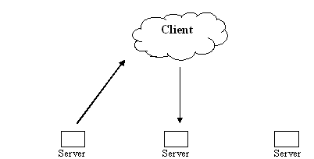
Fig.5. The token-holding-server redirecting the client to a new server.

The client is then “redirected” towards the new server using End-Point Operation Protocol (EOP) [12], which is a session layer protocol that wraps transport layer data with an EOP header in order to manage end-point movement for the lifetime of the associated communication channel.
The working of the protocol is simple enough. Referring to Fig. 6(a), its functionality can be summarized as follows:
After connecting to B, A sends its initial request, B uses the redirect system call to redirect requests to C. At A, EOP responds to the redirection request by closing the connection to B, opening a new connection to C, and then returning control to the client. Further requests, possibly including the previous request if B did not send a response with its redirect, are sent directly to C. At this point of time, B is fully divorced from A.
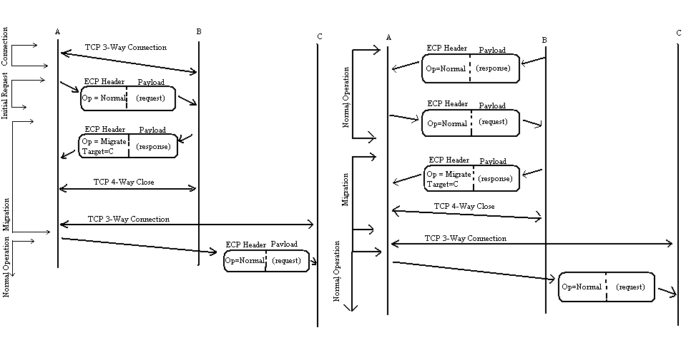
Fig.6. Timeline for EOP packet flow: a) Connection-time redirection
b) Instream redirection

The redirection may be achieved through HTTP redirection or the RedSocks redirection [12], though results show that RedSocks redirection fares better in End-Point Operation Protocol. The responsibility of maintaining the transparency, security and session-continuity rests with the implementation of EOP. To show the concept of redirectable sockets, consider the situation where in a communication channel exists between two nodes, A and B.

B
A
y
A
B
x
X
redirect

(a) Communication Channel (b) Redirect System Call

B
C
A
B
C
A
z
Z
(c) New connection creation (d) Communication on new channel

Fig. 7. Redirect end-point B to C.

The application at B then executes “redirect” in order to change the “B” end-point of the channel to C. C may be define an end-point at A, B, or at a different host. The “redirect” call creates a new channel between A and C, removes the channel between A and B.
The connection can be, again, redirected to a new third server if the present server realizes that it is going to crash or it can no longer support the connections.

Comparison with existing methods

The model scores over current methods in the following areas:

- Since there is no central receiving point, there is no speed bottleneck in this model. Moreover, such central dispatcher based run the risk of bringing the entire system down if the dispatcher goes down. In this model, the web-serving system continues its functions even if the one or two servers go down.
- It wins over the server side DNS approach as the clients cache the UDP multicast address and can use them time and again. Also the servers don’t need to refresh their load conditions entries in the DNS.
- The Network Address Translation approach is also vulnerable as the whole system goes down if the central router crashes. Moreover, the maximum number of connections that the servers can handle is based on the maximum capability of the central router. These shortcomings can be addressed through this approach.
- This model uses the content based redirection. This helps in speedy and more efficient servicing of data.
- Without any extra overhead, all the servers are being provided with a single IP address. The token system ensures that there is only one commanding server receiving requests from the clients at a time, and redirecting them to new appropriate servers, if needed.
- The redirect-ability of the connections provide for the fail-over support for the clients. Once the servicing server realizes that it is going to crash, it redirects the client to the next appropriate server.

CONCLUSION

We have proposed a new model that will go a long way in solving the problems of fault-tolerance, One-IP address, efficient load-balancing etc. At the time of writing this paper, the implementation could not be completed fully and the preliminary experiments were still being carried out. Due to scarcity of required resources, the implementation will be done on a simulator program, NS2 (copyrighted by the University of California, Berkeley). But the already proven results point that this model is better than existing methods. It improves upon the previous ad-hoc mechanisms for balancing load among servers in that it is scalable, balances load efficiently and transparent to the user. In future work, we will explore the issues of efficient implementation of the scheme as well as issues of application-transparency, security and session continuity.

