Middleware for Web-Based Manufacturing

Bhavin V. Mehta, Ph.D, Associate Professor
E-mail: mehta@ohio.edu
Yongjun Zhou, Research Assistant
Department of Mechanical Engineering
Ohio University, Athens, Ohio 45701, USA

Abstract

The research is part of the web-based Virtual Material Processing (VMP) project underway at Ohio University (OU). The primary objective of this project was to develop a methodology and software that will use Artificial Intelligence (AI), Simulation and Modeling coupled with VR (virtual reality concepts) and Resource Management (RM) for the automated design, analysis and visualization of various material forming processes. The environment is designed to be platform independent and accessible over the World Wide Web (WWW). Industry/Government researchers and academicians can access the environment and perform process selection, product design, development and simulation on the web. This paper focuses on the development of a middleware for load balancing and distributed/parallel processing of simulations and animations.
Keywords: Manufacturing, Web-Based, Material Processing, Load-Balancing, Distributed Processing

1 INTRODUCTION
Manufacturing is a complex process involving a wide variety of resources and activities such as product design, machinery, tooling, process planning, materials and purchasing. A manufacturing organization must make optimum use of all its resources like materials, machines, energy, capital, labor, and technology. Given a finished product, different manufacturing processes could be used to manufacture it. In a highly competitive environment, a chosen manufacturing process must be flexible enough to respond to changes in market demands, type of products, production rates, production quantities, and on-time delivery requirements. Manufacturing analysis is the process by which one could determine one or more suitable manufacturing processes by applying different manufacturing criteria.

To design and develop a new product in a Virtual Manufacturing environment there are several processes like Extrusion, Rolling, Forging, Casting, Machining etc., which have to be analyzed. The simulation time varies by process and product complexity. Depending on the product, some processes might be connected and the simulation/analysis has to be performed in a particular order. Resource allocation on the server is very important to obtain optimum performance and attain new product development in a timely and cost effective fashion. The essence of our solution is first step in a collaborative partnership between applications and the operating system. This can be achieved by monitoring the level and quality of resources and by informing applications about any relevant changes in their environment and scheduling them according to their priority and process time requirements. Environmental changes include memory allocation, CPU usage, priority, time-quanta and even the server it-self in a distributed environment. Applications must be agile, that is able to receive events in an asynchronous manner and react appropriately. There is a need for a central point for managing resources and authorizing any application initiated request for their use. Just like express mail versus normal mail, the user could request a fast analysis at a higher cost; the resource management module would then allocate a higher priority and a larger time-quantum and/or change the priority class to accommodate the expedited analysis request. The priority and time quanta along with memory allocation management can be implemented with-in the web-based manufacturing environment to obtain optimum productivity for virtual prototyping.
It is an axiom in the server world that one can never have enough capacity. Disk space, memory and available processing power have a way of disappearing faster than ever. Applications can quickly expand beyond the limits of any single platform. One needs to ensure optimum uptime, availability, and performance of the entire virtual manufacturing application. We need to provide solutions that actively monitor, control, and assure service levels of applications with timeliness and cost effective solution. The final outcome is to deliver high quality product to end user by facilitating cost effective quality of service. A resource manager is one type of middleware in which the requirements for correct operation and efficient service include timeliness of simulations or order processing in the virtual manufacturing applications.

2 VIRTUAL MATERIAL PROCESSING ENVIRONMENT
Virtual manufacturing can be considered one of the enabling technologies for the rapidly developing information technology infrastructure. The motivation is to enhance our ability to predict potential problems and inefficiencies in product functionality and manufacturability before real manufacturing occurs. The main objective of this research is to create an environment for the Internet that would allow users around the world to intelligently select process sequence, design dies and molds, and analyze the forming processes like Extrusion, Rolling, Forging, Casting, and Sheet Metal Forming (Figure 1).
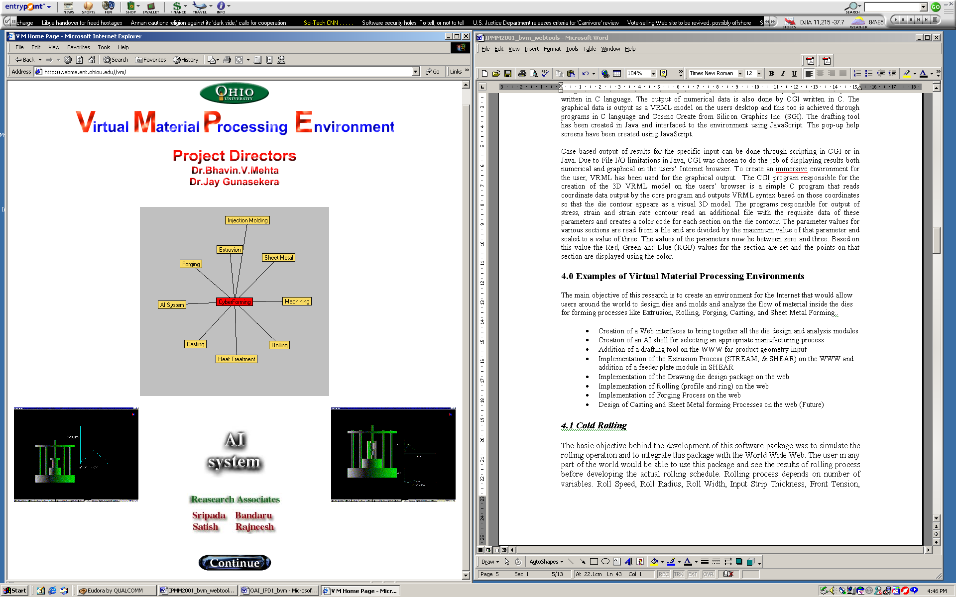
Figure 1: Front Page of the VMP Environment

The objective is to design a part on the web using the modeling tool or upload a DXF/STEP file, recommend a suitable manufacturing process for achieving the final product shape by providing the user the option of designing the appropriate dies and molds, and then carrying out the analysis using Slab method, Upper-Bound or Finite Element method and visualizing the manufacturing process in an immersive and interactive environment (Figure 2).
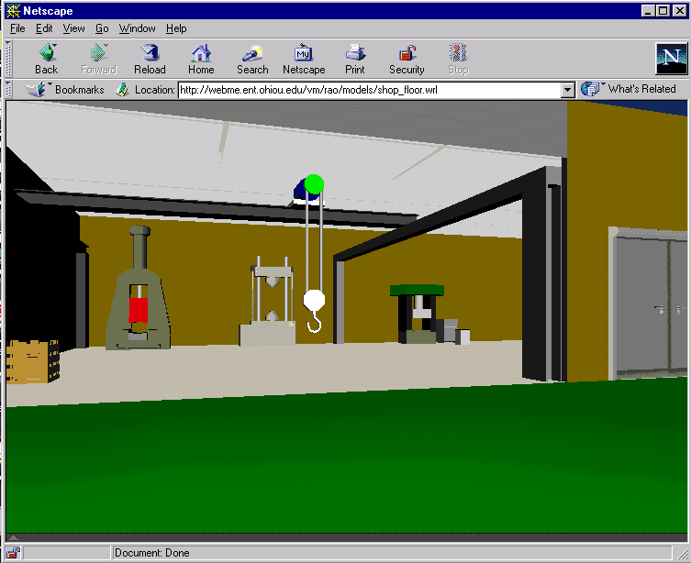
Figure 2: Virtual Workshop

The researcher can evaluate competing processes and also learn about forming processes through the web-based tutorials and training material. It is an ideal tool for research, experimentation and training. Tools like Java, CGM, VRML, and other tool-kits were used to develop the interfaces and programs to run under Netscape and Internet Explorer.

The programs/packages for die design, slab and upper bound solutions for flow analysis and material selection, developed in-house, are being used to support the real-time virtual material processing environment. The environment is fully distributed and can be accessed from anywhere in the world using the Internet. The user accesses the VMP system using a web browser on their desktop, provides the necessary data which is send to the web server, which in-turn sends it to the appropriate solver on the Silicon Graphics machine, Sun Server, or the Supercomputer. The graphical and numerical results are displayed on the user’s desktop/browser. The user has the choice of saving the data in the database and/or downloading it for further analysis, report generation and confidentiality. Resource management tools will be very beneficial in optimally executing the simulation modules with-in the virtual manufacturing environment and dynamically updating the priorities, and time-quanta of the analysis process when required.

3 LOAD BALANCING AND DISTRIBUTED PROCESSING
Applications such as Web servers, File Transfer Protocol servers, and database servers can quickly expand beyond the limits of any single platform. One way to surpass the limitations is load balancing. By distributing your web server load among multiple machines, better performance and scalability are achieved. Load balancing can be done through hardware or software based techniques. In this thesis, we mainly focus on the software base technique.

One technique, called DNS load balancing, involves maintaining identical copies of the site on physically separate servers. The DNS entry for the site is set to return multiple IP addresses, each corresponding to the different copies of the site. The DNS server then returns a different IP address for each request it receives, cycling through the multiple IP addresses. This method gives you a very basic implementation of load balancing.

Another load-balancing technique involves a multi-node "cluster" architecture that provides high availability and scalability. Such an architecture distributes the load so that if one of the hosts in the sever facility were to fail, the load will be distributed among the remaining hosts without any service interruption. This architecture is called "clustering," and is more reliable than the DNS load balancing technique because of the design of its topology. In this thesis, we will mainly focus on clustering architecture. Clustering topologies employ a 'heartbeat mechanism' within each server to monitor server health. The primary server sends periodic messages to the alternate server to determine whether the server is functioning properly. If the flow of messages is impeded for any reason, then the viable server assumes that the other server has experienced a fatal failure and puts itself into operation in place of the failed server. This intelligent mode of server distribution is the preferred method of cluster-based load balancing, and assumes two forms: passive and active.

A passive load balance arrangement is when one server acts as a primary server, with a secondary server only available for use should a failure occur in the primary server. With the passive approach, a secondary server is never used for any other processing except in the event of a failure. Conversely, the active load balance approach distributes all incoming request among both the primary and secondary server in the cluster. Usually it is more cost-effective and efficient to use the active method in order to improve the performance of a busy site. In this research, we use active load balance approach.

Active clustering technology involves two important steps, one is intercepting HTTP requests and another is monitoring the health conditions of the servers. The ability to analyze what the server receives before it does anything with the request data makes it possible to improve security and efficiently handle both server errors and user mistakes. Additionally, request analysis allows for proactive measures to be taken in terms of better code reuse and resource allocation on the part of a software development team. Since the web-based manufacturing environment involves simulation software, just load balancing and distributing is not enough for optimum performance. Along with load balancing and distributed processing, the middleware will take into account the server memory, processor speed, CPU usage and intelligently perform load balancing.

4 CONCLUSIONS

The creation of this engineering software package will be of great help to the Material Processing/Manufacturing industry, as the manufacturer can reduce the use of trial-and-error ("make and break") method of manufacturing/prototyping, which involves waste of materials and manpower. Integration of Virtual Material Processing (VMP) environment with the Internet is a new concept and is still under development. The middleware with efficient load balancing, resource management and distributed processing will provide added convenience, speed and cost optimization for researchers using the environment.

5 REFERENCES

- B. V. Mehta, CyberForm: Web-based Material Processing--Demo, Proceedings of IPMM 2001, Vancouver, BC, Canada, July 2001.
- B. V. Mehta, Web-based and Distributed Material Processing, Proceedings of the 7th International Conference on High Performance Computing, Bangalore, India, Dec. 2000.
- B. V. Mehta, R. Banga, J. Gunasekera, Virtual Material Processing on the WWW: Cold Rolling, 18th ASME International Computers in Engineering Conference, Las Vegas, Nevada, Sept. 12-16, 1999.
- B. V. Mehta, J. S. Gunasekera, S. Shivananda, Virtual Material Processing (VMP) on the WEB: Extrusion Die Design, Journal of Manufacturing Systems, Vol. 29, No. 3, 1999.
- http://www.sun.com/
- J. Hartman, VRML 2.0 Handbook, Addison-Wesley, 1996
- B. Avitzur, Handbook of Metal Forming processes, John Wiley and Sons, 1983
- V. Rao, Design and Analysis of Virtual Systems for Manufacturing, MS Thesis, 2001, Advisor: Dr. B. V. Mehta
- S. Shivananda, Virtual Manufacturing: Extrusion Die Design, MS Thesis, 1988. Advisor: Dr. B. V. Mehta
- V. Bandara, Virtual Manufacturing: Drawing Die Design, MS Thesis, 1999. Advisor: Dr. B. V. Mehta
- R. Banga, Web-Based Cold Rolling, MS Thesis, 1999, Advisor: Dr. B. V. Mehta
- U. Shetty, Interactive Extrusion Machine, MS Thesis, 2001, Advisor: Dr. B. V. Mehta
- S. Duttala, Virtual Material Processing: AI Based Process Selection, MS Thesis, 2001, Advisor: Dr. B. V. Mehta
- B. V. Mehta, H. A. Hamza, R. Gerth, A New Methodology of Using Design of Experiments as A Precursor to Neural Networks for Material Processing: Extrusion Die Design, JOM- Journal of Metals, Minerals and Materials, Vol. 51 (9), Sept. 1999, pp. 1-7.
- S. Shivananda, V. Rao, B. Venkata, J. Gunasekera, and B. V. Mehta, Virtual Reality Applications in Material Processing on the World Wide Web (WWW): Extrusion Die Design, CIRP 1997 International Design Seminar Proceedings, Los Angeles, CA, Oct. 8-10, 1997, pp. 162.

